

**Karen Kimsey-House, MFA, CPCC, MCC**

**Co-founder, CEO & Director, CTI**

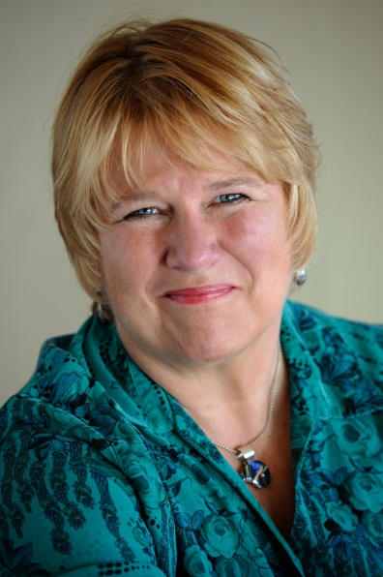

One of the earliest recognized luminaries in the coaching profession, Kimsey-House founded CTI in 1992 with Laura Whitworth and Henry Kimsey-House. They created the Co-Active philosophy of relationship that informs CTI’s world-renowned coaching and leadership programs. She also is a blogger for *The Huffington Post* and the co-author of *Co-Active Coaching*, the best-selling industry bible, now in its third edition. A successful entrepreneur, Kimsey-House founded and directed the Learning Annex San Francisco adult education program in 1986 and grew it into one of the most admired programs under the national Learning Annex brand. She received her MFA in Communications and Theater from Temple University in Philadelphia. Committed to pioneering Co-Activity in challenged environments and troubled populations, Kimsey-House continues to lead CTI workshops and is a dynamic keynote speaker around the world. On a mission of global, transformative change, she lives with her husband, Henry Kimsey-House, by the Pacific Ocean.